**Positioning Statement and Focal Points**

By Mousfiqul Islam Khan

1. Positioning Statement

For the Enterprise as a whole:

NyGen (IT company, provides IT support to other businesses reducing their need to have an IT department for themselves). Unlike other firms who provide IT services on a contractual basis, NyGen acts as a permanent consultant. They have various clients from small firms to big corporations, providing either an extra assistance to any IT related issues, or sometimes they handle all of the IT related problems faced by the business.

For their Digital Platform:

For IT technicians who work at NyGen, NyApp is an enterprise software that will improve their ability to be more efficient on field jobs and enhance the maintenance experience overall. Unlike the current solution where technicians have to call back and wait for answers to queries, NyApp gives the technicians the ability to easily find what they are looking for, and drastically improve both technician and customer experience.

1. Focal Questions
2. What’s important to the business? Why? How is it measured with regard to customer/user behavior?

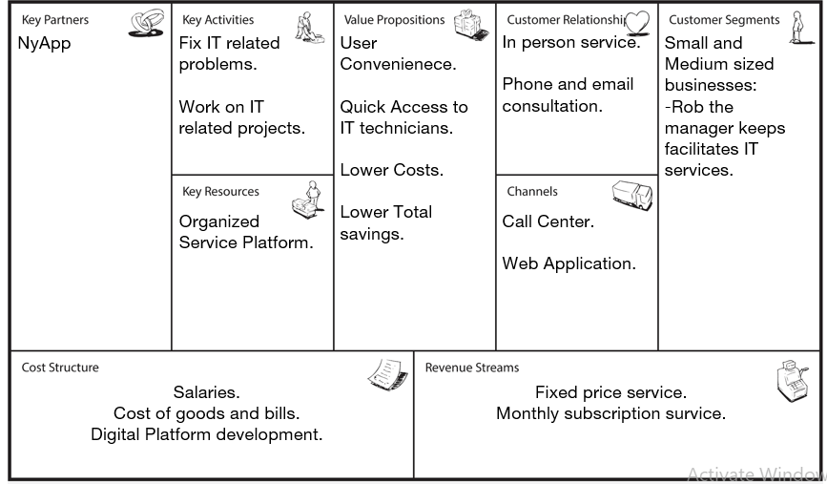NyGen’s core market are small and medium sized companies. The most important thing is to be able to provide high quality IT service at an affordable price.

Customers of these segments highly value the ability to have their IT problems fixed without having to worry about creating an entire IT department of their own. Our ability to provide these convenient value propositions is what sets us apart and it can be visibly measured by the amount of orders we get.

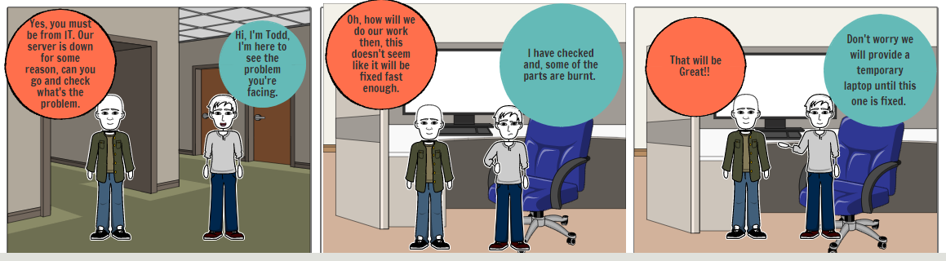

|  |  |  |
| --- | --- | --- |
| Panel | Notes | Questions Observations/metrics |
| A | The customer has an urgent IT problem which needs immediate attention. | -How often do we get these calls in regard to the type of problem?  Metrics:  Inbound calls and queries  Answer: What’s the problem? (Try to walk through a solution, if it’s too hard to solve, tell them you are sending a representative.) |

1. For which problem scenario/Job-to-be-done should we test new proposition?

|  |  |
| --- | --- |
| Problem Scenario | Demand/Value Hypothesis |
| Helping Customer service representatives to be better equipped to handle a IT related phone call. | If we give the Customer service representatives a list of common problems and their solutions then they could help customers. If the problem needs more attention then we’ll send a IT technician. |
| Enable IT technicians to see all the documentations of products and services and make orders on field for a swifter job which would result in better customer experience. | If we provide a way to search for all documents and products on one platform to check prices and make orders on spot, then the techs will use it and it will improve outcome. |

1. How will we define the measure of success?

|  |  |
| --- | --- |
| Problem Scenario/Job-to-be-done | Measuring Success/Outcomes |
| Helping Customer service representatives to be better equipped to handle a IT related phone call. | How many representatives use our tools to help customers successfully? |
| Enable IT technicians to see all the documentations of products and services and make orders on field for a swifter job which would result in better customer experience. | How many times the platform is accessed and how many times an order was placed? |